**Assumptions:**

* A Page and a Profile are accounts and therefore have an account id which is an integer that increments by 1 each time a new account is created starting from 0.
* An account can create a post, and each post will have a unique int id which starts from 3000 and is incremented by 1 every time a new post is created.
* A profile will also have a unique int id which starts from 1000 and is incremented by 1 every time a new profile is created in addition to having a unique account id.
* A post receives views and within each view the account id of the viewer and the time it is viewed is recorded.
* A post which can be either a text, audio, video, or image contains comments and each comment has a unique int id which starts from 4000 and increments every time a comment in a post it is contained by is added. Only the account can create their post.
* A comment can receive a like. When that happens the comment id, the account id of the person who liked it and the time are recorded.
* An account can send and receive messages. The time sent, the recipient account id, and the sender account id act as the primary keys.
* A Page can be categorized and each category has a unique int id and has a string that corresponds to that id to decrease redundancy. A page must have a category
* I used PostgreSQL on the Google Cloud Platform as my DBMS
* All queries are made from the backend sever which runs on nodejs and is deployed on Heroku
* Web app: <https://cse3330-221718.firebaseapp.com>
* Code Repo: <https://github.com/ondikumana/CSE3330>

**Relations**

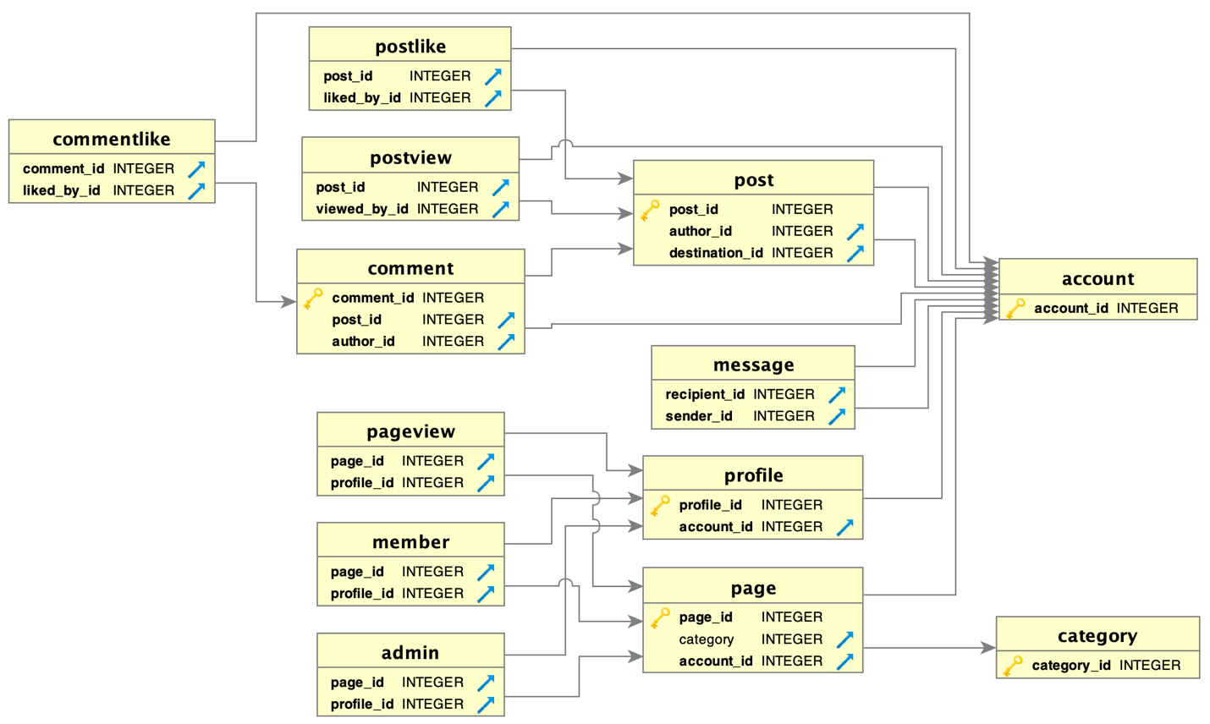

**Tables**

CREATE SEQUENCE account_id_seq start 38 increment 1; --Usually starts from 1

CREATE TABLE Account (

account_id INT NOT NULL DEFAULT nextval('account_id_seq') PRIMARY KEY,

creation_date TIMESTAMP DEFAULT CURRENT_TIMESTAMP,

account_type VARCHAR(7) NOT NULL

);

CREATE SEQUENCE category_id_seq start 25 increment 1; --Usually starts from 20

CREATE TABLE Category (

category_id INT NOT NULL DEFAULT nextval('category_id_seq') PRIMARY KEY,

category_description VARCHAR(100) UNIQUE NOT NULL

);

CREATE SEQUENCE page_id_seq start 2004 increment 1;--Usually starts from 2000

CREATE TABLE Page (

page_id INT NOT NULL DEFAULT nextval('page_id_seq') PRIMARY KEY,

page_name VARCHAR(100) NOT NULL,

logo_url VARCHAR(300),

header_image_url VARCHAR(300),

description VARCHAR(2000),

category INT,

account_id INT NOT NULL

);

ALTER TABLE Page ADD FOREIGN KEY (category) REFERENCES Category(category_id) ON DELETE SET NULL;

ALTER TABLE Page ADD FOREIGN KEY (account_id) REFERENCES Account(account_id) ON DELETE CASCADE;

CREATE SEQUENCE profile_id_seq start 1021 increment 1; --Usually starts from 1000

CREATE TABLE Profile (

profile_id INT NOT NULL DEFAULT nextval('profile_id_seq') PRIMARY KEY,

fname VARCHAR(100) NOT NULL,

lname VARCHAR(100) NOT NULL,

phone VARCHAR(12) NOT NULL,

email VARCHAR(100) NOT NULL UNIQUE,

username VARCHAR(12) NOT NULL UNIQUE,

password VARCHAR(12) NOT NULL,

account_id INT NOT NULL

);

ALTER TABLE Profile ADD FOREIGN KEY (account_id) REFERENCES Account(account_id) ON DELETE CASCADE;

CREATE TABLE Member (

page_id INT NOT NULL,

profile_id INT NOT NULL ,

join_date TIMESTAMP DEFAULT CURRENT_TIMESTAMP

);

ALTER TABLE Member ADD CONSTRAINT unique_member UNIQUE(page_id, profile_id);

ALTER TABLE Member ADD FOREIGN KEY (page_id) REFERENCES Page(page_id) ON DELETE CASCADE;

ALTER TABLE Member ADD FOREIGN KEY (profile_id) REFERENCES Profile(profile_id) ON DELETE CASCADE;

CREATE TABLE PageView (

page_id INT NOT NULL,

profile_id INT NOT NULL,

time TIMESTAMP DEFAULT CURRENT_TIMESTAMP

);

ALTER TABLE PageView ADD CONSTRAINT unique_pageview UNIQUE(page_id, profile_id);

ALTER TABLE PageView ADD FOREIGN KEY (page_id) REFERENCES Page(page_id) ON DELETE CASCADE;

ALTER TABLE PageView ADD FOREIGN KEY (profile_id) REFERENCES Profile(profile_id) ON DELETE CASCADE;

CREATE TABLE Admin (

page_id INT NOT NULL,

profile_id INT NOT NULL,

admin_since_date TIMESTAMP DEFAULT CURRENT_TIMESTAMP

);

ALTER TABLE Admin ADD CONSTRAINT unique_admin UNIQUE(page_id, profile_id);

ALTER TABLE Admin ADD FOREIGN KEY (page_id) REFERENCES Page(page_id) ON DELETE CASCADE;

ALTER TABLE Admin ADD FOREIGN KEY (profile_id) REFERENCES Profile(profile_id) ON DELETE CASCADE;

CREATE TABLE Message (

recipient_id INT NOT NULL,

sender_id INT NOT NULL,

sent_time TIMESTAMP DEFAULT CURRENT_TIMESTAMP,

was_sent BOOLEAN,

was_delivered BOOLEAN,

was_read BOOLEAN,

body VARCHAR(2000) NOT NULL

);

ALTER TABLE Message ADD FOREIGN KEY (recipient_id) REFERENCES Account(account_id) ON DELETE CASCADE;

ALTER TABLE Message ADD FOREIGN KEY (sender_id) REFERENCES Account(account_id) ON DELETE CASCADE;

CREATE SEQUENCE post_id_seq start 3013 increment 1; --Usually starts from 3000

CREATE TABLE Post (

post_id INT NOT NULL DEFAULT nextval('post_id_seq') PRIMARY KEY,

time TIMESTAMP DEFAULT CURRENT_TIMESTAMP,

author_id INT NOT NULL,

destination_id INT NOT NULL,

attachment_url VARCHAR(200),

body VARCHAR(2000) NOT NULL

);

ALTER TABLE Post ADD FOREIGN KEY (author_id) REFERENCES Account(account_id) ON DELETE CASCADE;

ALTER TABLE Post ADD FOREIGN KEY (destination_id) REFERENCES Account(account_id) ON DELETE CASCADE;

CREATE TABLE PostLike (

post_id INT NOT NULL,

liked_by_id INT NOT NULL,

time TIMESTAMP DEFAULT CURRENT_TIMESTAMP

);

ALTER TABLE PostLike ADD FOREIGN KEY (post_id) REFERENCES Post(post_id) ON DELETE CASCADE;

ALTER TABLE PostLike ADD FOREIGN KEY (liked_by_id) REFERENCES Account(account_id) ON DELETE CASCADE;

ALTER TABLE PostLike ADD CONSTRAINT unique_postlike UNIQUE(post_id, liked_by_id);

CREATE TABLE PostView (

post_id INT NOT NULL,

viewed_by_id INT NOT NULL,

time TIMESTAMP DEFAULT CURRENT_TIMESTAMP

);

ALTER TABLE PostView ADD FOREIGN KEY (post_id) REFERENCES Post(post_id) ON DELETE CASCADE;

ALTER TABLE PostView ADD FOREIGN KEY (viewed_by_id) REFERENCES Account(account_id) ON DELETE CASCADE;

ALTER TABLE PostView ADD CONSTRAINT unique_postview UNIQUE(post_id, viewed_by_id);

CREATE SEQUENCE comment_id_seq start 4014 increment 1; --Usually starts from 4000

CREATE TABLE Comment (

comment_id INT NOT NULL DEFAULT nextval('comment_id_seq') PRIMARY KEY,

post_id INT NOT NULL,

time TIMESTAMP DEFAULT CURRENT_TIMESTAMP,

author_id INT NOT NULL,

attachment_url VARCHAR(200),

body VARCHAR(2000) NOT NULL

);

ALTER TABLE Comment ADD FOREIGN KEY (post_id) REFERENCES Post(post_id) ON DELETE CASCADE;

ALTER TABLE Comment ADD FOREIGN KEY (author_id) REFERENCES Account(account_id) ON DELETE CASCADE;

CREATE TABLE CommentLike (

comment_id INT NOT NULL,

liked_by_id INT NOT NULL,

time TIMESTAMP DEFAULT CURRENT_TIMESTAMP

);

ALTER TABLE CommentLike ADD FOREIGN KEY (comment_id) REFERENCES Comment(comment_id) ON DELETE CASCADE;

ALTER TABLE CommentLike ADD FOREIGN KEY (liked_by_id) REFERENCES Account(account_id) ON DELETE CASCADE;

ALTER TABLE CommentLike ADD CONSTRAINT unique_commentlike UNIQUE(comment_id, liked_by_id);